Monday | January 1, 2024 |  |  |  | Issue 01
Sunset Springs Community
 | THE DIGITAL NEWSPAPER
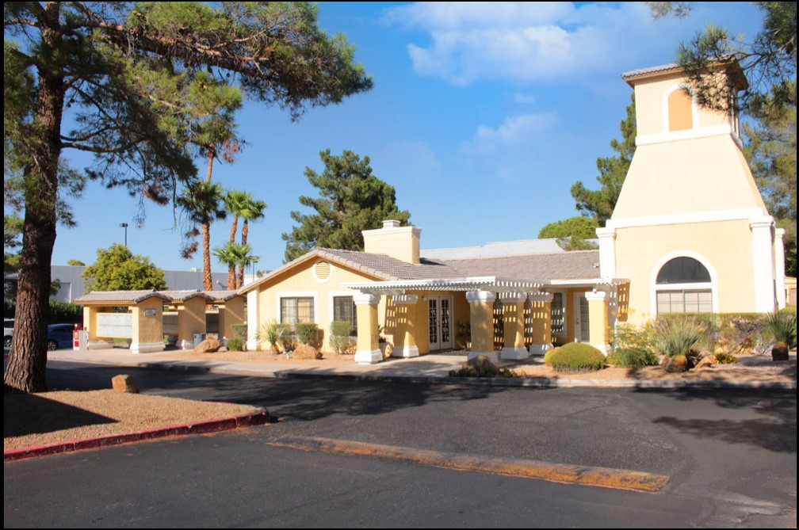 |  |  |  | Community Updates & Reminders (1)  --------------------------  - Xeriscaping of the property is just about complete.  - Next future project will be a dog park.  - Arcadia Security Dispatch number is: 1 (844) 587-2876 Report any suspicious activity.  - Rent is late on the 4th. Late fee is 5% of the total rent.  - Be sure and change your a/c filter at least once a month. Air filters are provided at the office.  - Smoke detector batteries are at the office. If your smoke detector is chirping it needs to be changed.  - Be sure your car’s registration is up to date and in working condition.    Classic Deviled Eggs Recipe:  *Ingredients  6 hard-cooked eggs, peeled  3 tbs mayonnaise  ½ teaspoon ground mustard  1/8 teaspoon salt  1/8 teaspoon pepper  Paprika, if desired  Steps  - Cut eggs lengthwise in half. Slip out yolks and mash with fork.  - In a small bowl, mash yolks with for. Add the mayonnaise, salt, mustard, and pepper. Mix well. Stuff or pipe into egg whites. If desired sprinkle with paprika. Refrigerate until serving.  ENJOY!
Sunset Springs Apartments
6930 Paradise Road
Las Vegas, NV 89119
(702) 361-0694
(702) 361-9645 Fax
Upcomming events/projects
New project: Dog park |  | Lighting Updates
Introducing a dog park to our apartment community would be a fantastic addition, enhancing the quality of life for both residents and their furry companions. Imagine a designated space where dogs can run, play, and socialize, fostering a sense of community among neighbors.  The park would not only provide a hub for canine energy release but also create opportunities for residents to connect, share experiences, and build lasting friendships. This addition would not just be a recreational space; it would be a vibrant center for joy, exercise, and community bonding, making our apartment complex an even more enjoyable and fulfilling place to live.   |  | Lighting around the community will be getting an update. LED bulbs and lighting will be used around the property to better light dark areas at night.  Carports will also be getting the updated LED bulbs and fixtures. Along with the building lights and hallway light fixtures.
 |  | TRIANNUAL INSPECTIONS
Our Triannual inspections this year will be on February, June and October. Letters will be on doors 24hrs prior to inspection. Our main focus for the inspection are leaks from sinks, smoke detectors and changing air filters.


Monday January 1, 2024
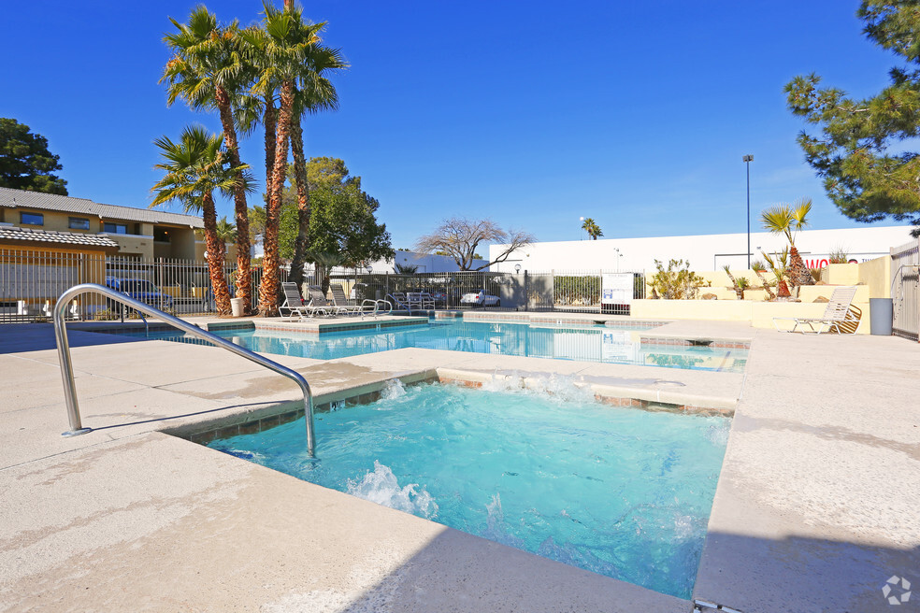 |  |  |  | Gym Policies & Reminders (II)  --------------------------  - Residents and guests will follow all posted rules and regulations within the fitness center.  - No one under the age of 18yrs can be in the fitness center at any time.  - Fitness center hours are from 8am-10pm Monday-Sunday.  - If there are any updates to email or phone numbers, please call or go to the office.  - In case of emergency call 911.  - In case of maintenance emergency after hours call the office and go through our answering service at (702) 361-0694  - Please do not feed the pigeons.  - If trash is being thrown away, please do not place it by your door for it will attract unwanted pests.  - ONLY firewood is permitted in the fireplace. No artificial substances such as Duraflame logs.  - Please see your lease for all policies and regulations. A copy can be provided from the office.  
Community Policies Reminder
POOL, SPA AND SAUNA POLICIES  - Tenants and guests will follow all posted rules and regulations within the pool/spa/sauna.  - No one under the age of 14 are allowed in the pool, spa or sauna without parent supervision.  - No glassware, alcoholic beverages or pets permitted in pool, spa or sauna area.  - Prohibited types of conduct within these areas (ie running, roughhousing, being excessively loud or engaging in obscene behavior.   |  | PET POLICY  - All pets must be on a leash at all times.  - Pet must not be unattended in patios.  - Clean up and properly dispose of pet waste. Failure to do so will result in a $500.00 violation fee for each occurrence.  - Unauthorized pets will result in a $500.00 violation fee.  

Fun facts: “About dogs”

Did you know that dogs can learn over 100 words and gestures?
Dogs are thought to be as smart as two-year-old children
(and much easier to train!), so many owners teach them
commands and tricks.
Policies and Reminders (III) |  | - Residents must refrain from parking in any covered space that is assigned to another resident at the property.  - Do not park in any area clearly marked as a fire zone or emergency response lane.  - There are certain items that should NEVER go down your garbage disposal as they will clog and or damage your disposal such as rice, potatoes, carrots, banana peels, onion skins, COOKING OIL/GREASE, metal objects, bones. * see lease for more. | - HAVE ANY QUESTIONS?  - HAVE ANY COMMENTS?  - WANT TO SHARE SOMETHING ON OUR NEXT NEWSLETTER?  - SHARE A RECIPE?  -Feel free to email us at sunsetspringsfamily@gmail.com
- BBQ’s and other open flame cooking devices (including electronic grills) shall not be operated on balconies under any circumstances.
- The front office will not accept delivery of any parcels and packages on behalf of residents.
- Washing, Cleaning, Paining, repairing or servicing any automobile or cycle is prohibited on property.
2 |  |  |  |  | Issue 01

